Architecture Documentation
AI Summer Internship 2026
Assignment 5
Title: Vision Toolkit Architecture Documentation
Submitted By: Muhammad Saqlain
Department: BS Artificial Intelligence
University: The University of Faisalabad

System Architecture
The diagram below illustrates the end-to-end flow of the Vision Toolkit application, from the moment a user uploads an image through to the final saved output.
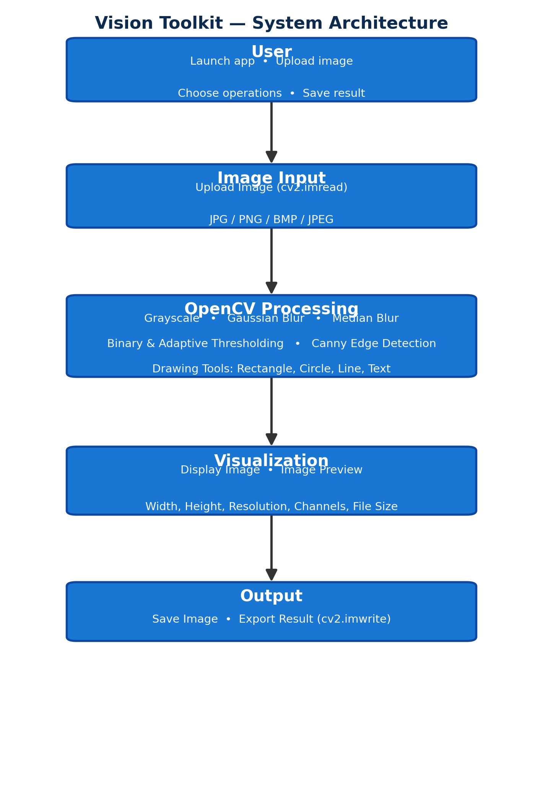
Figure 1: Vision Toolkit Architecture — five-stage processing pipeline

Stage 1 – User
The user is the starting point of the Vision Toolkit application. The user interacts with the graphical interface to upload an image and select different image processing operations. The application is designed to provide an easy-to-use interface where users can perform computer vision tasks without writing code.
Responsibilities
- Launch the application
- Upload an image
- Choose image processing operations
- Save the processed image

Stage 2 – Image Input
The Image Input module receives images from the user through a file dialog. OpenCV loads the selected image into memory using the cv2.imread() function. The application supports common image formats such as JPG, PNG, BMP, and JPEG.
Functions
- Browse image
- Load image
- Validate image format
- Store image in memory

Stage 3 – OpenCV Processing
This is the core processing module of the application. It applies various computer vision algorithms to the uploaded image.
Processing Operations
- Grayscale Conversion
- Gaussian Blur
- Median Blur
- Binary Thresholding
- Adaptive Thresholding
- Canny Edge Detection
- Drawing Rectangle
- Drawing Circle
- Drawing Line
- Adding Text
Each operation transforms the original image into a processed version while preserving the original image.

Stage 4 – Visualization
The Visualization module displays the processed image on the application's interface. It also presents important image information such as width, height, resolution, number of channels, and file size.
Displayed Information
- Original image
- Processed image
- Width
- Height
- Resolution
- Channels
- File size
This module provides immediate visual feedback to the user after every processing operation.

Stage 5 – Output
The Output module allows the user to save the processed image. The application writes the processed image to disk using OpenCV's cv2.imwrite() function.
Output Features
- Save processed image
- Export edited image
- Preserve image quality
- Store in output directory

Technologies Used
Technology | Purpose
Python | Programming Language
OpenCV | Image Processing
Tkinter | Graphical User Interface
NumPy | Numerical Operations
Pillow | Image Display
VS Code | Development Environment

Conclusion
The Vision Toolkit follows a simple and modular architecture. The user uploads an image, which is processed using OpenCV algorithms. The processed image is visualized in the graphical interface and can be saved as the final output. This architecture ensures that the application is easy to use, maintain, and extend with additional computer vision features in the future.

